AWS EC2 Deployment Documentation

LaunchOps AI is a Unified Multimodal AI Engine that turns simple product inputs into professional e-commerce launch assets. It generates studio photos, cinematic promotional ads, and marketplace-ready catalog listings instantly from rough photos, videos, text prompts, or voice descriptions.
This document covers the complete end-to-end deployment of the Unicom AI project on AWS EC2 using Docker Compose with an Nginx reverse proxy.

Step-by-Step Deployment Guide

Step 1: Launch EC2 Instance
- Go to AWS EC2 Console → Launch Instance
- Choose Ubuntu Server 26.04 LTS AMI
- Select t3.micro (free tier eligible)
- Create a new key pair → download unicom-key.pem
Configure Security Group:
  - Add SSH (Port 22) — Source: Anywhere
  - Add HTTP (Port 80) — Source: Anywhere
- Set Storage to 20 GiB (gp3)
- Click Launch Instance

Step 2: Expand Disk & Add Swap Memory
The t3.micro has 1 GiB RAM. The frontend Vite build requires ~1.5 GiB, so we need Swap memory.

Expand the partition:
- $ sudo growpart /dev/nvme0n1 1
- $ sudo resize2fs /dev/nvme0n1p1
- $ df -h /
Expected output: 19G total, ~15G available
Add 2GB Swap Memory:
- $ sudo fallocate -l 2G /swapfile
- $ sudo chmod 600 /swapfile
- $ sudo mkswap /swapfile
- $ sudo swapon /swapfile
- $ free -h # Verify swap is active

Step 3: Connect to EC2 via SSH

$ cd ~/Downloads

$ ssh -i "unicom-key.pem" ubuntu@<YOUR_EC2_PUBLIC_IP>

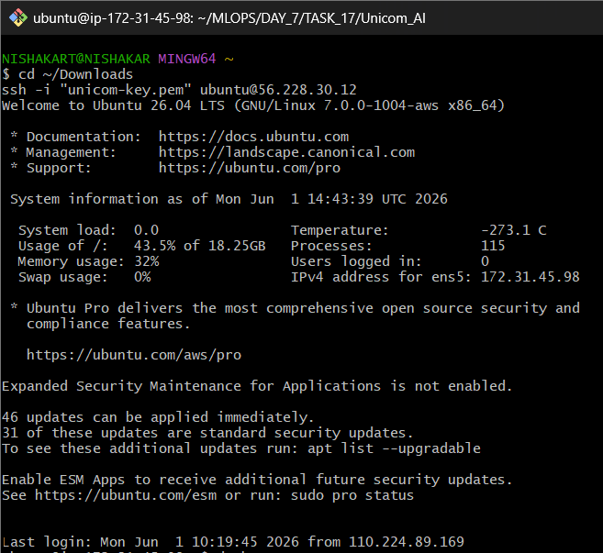

Step 4: Install Docker on the Server

- $ sudo apt update -y
- $ sudo apt install docker.io docker-compose-v2 -y
- $ sudo systemctl start docker
- $ sudo systemctl enable docker
- $ sudo usermod -aG docker ubuntu

Step 5: Clone the Project

Step 6: Build and Launch All Services
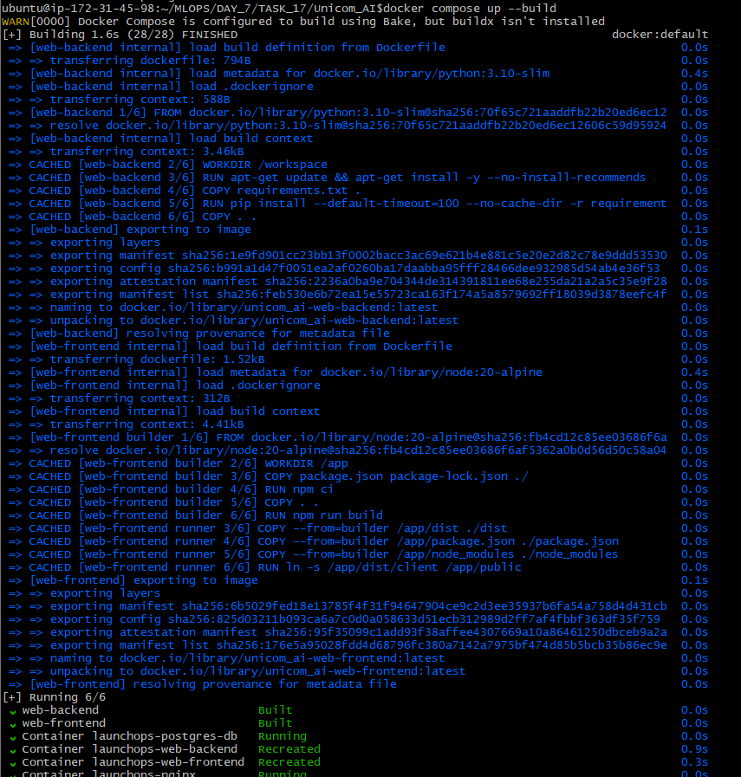
- docker compose up -d --build

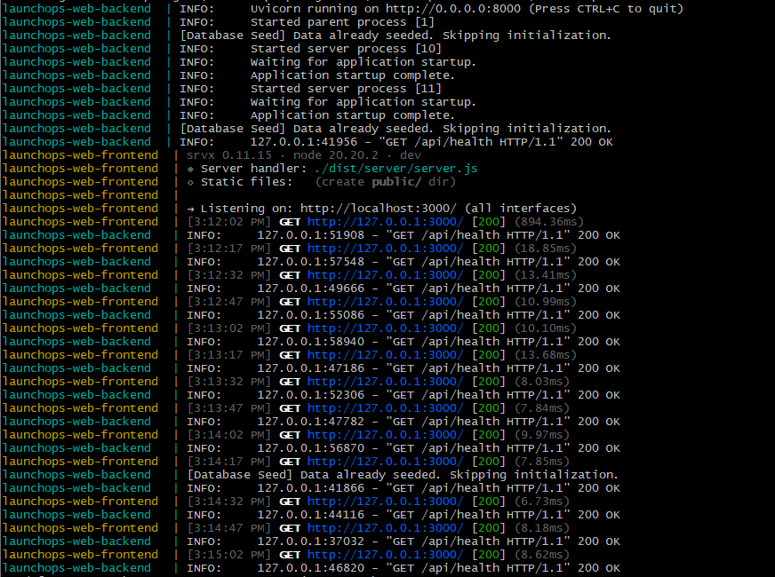

Live Application
- URL: http://13.53.51.73

